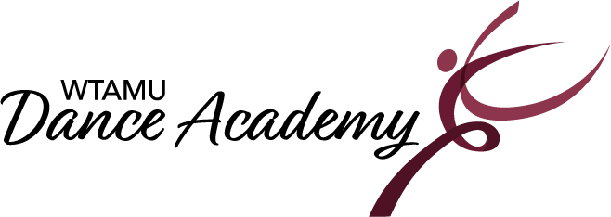
2023-2024 Important Dates

*Registration Dates: August 5th from 9:00-12:00.
August 12th from 1:00-3:00.
August 19th from 9:00-12:00.
Classes Begin: August 21st, 2023.
Classes End & Last day to register/add a class: December 2nd, 2023.
Classes Resume: January 8th, 2024.
Classes End: May 3rd, 2024.
Dress Rehearsal for Recital: May 4th, 2024.
Recital: May 5th, 2024.

Holidays/ No Classes:
September 4th: Labor Day
November 20th – 25th: Thanksgiving Break
December 3rd – January 7th: Winter Break
January 15th: Martin Luther King Jr. Day
March 11th – 16th: Spring Break
March 29th: Good Friday
*Registration is on-going until December 2.

